Three Foci
by T.S. Stephens

Vision really is an attending process. Humans struggle when we have too many to give focus and attention. The most common example is those who text while driving. They often fail in their driving focus yielding to accidents and deaths. Despite all of Satan's distractions, I would suggest to you there are three important foci for Christians.
First, Christians must focus upward to glorify Jesus and God. Hebrews 12:1-2 reminds us to focus on Christ: "Wherefore seeing we also are compassed about with so great a cloud of witnesses, let us lay aside every weight, and the sin which doth so easily beset us, and let us run with patience the race that is set before us, Looking unto Jesus the author and finisher of our faith; who for the joy that was set before him endured the cross, despising the shame, and is set down at the right hand of the throne of God."
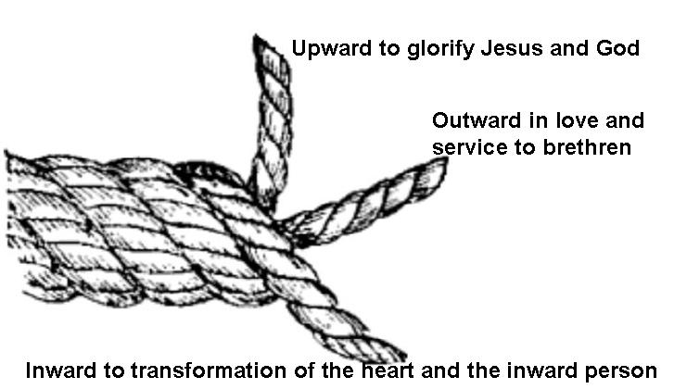
Second, Christians should focus outward in love and service to brethren. Romans 12:15-16 instructs, "Rejoice with them that do rejoice, and weep with them that weep. Be of the same mind one toward another. Mind not high things, but condescend to men of low estate. Be not wise in your own conceits." Likewise, John writes to encourage children of Light in this outward focus in 1 John 1:7: "But if we walk in the light, as he is in the light, we have fellowship one with another, and the blood of Jesus Christ his Son cleanseth us from all sin." In John 3:11, he writes, "For this is the message that ye heard from the beginning, that we should love one another." In 3:18, he reminds God's children, "My little children, let us not love in word, neither in tongue; but in deed and in truth."
Third, Christians should focus on the transformation of the heart and the inward person. Satan is using all of his carnal tools -- the lust of the flesh, the lust of the eyes, and the pride of life -- to enslave us. Christians must seek to be transformed in the renewing of their minds to holiness and righteousness. Christians are image bearers of God, reflecting his light and love. Romans 12:1-2 teaches, "I beseech you therefore, brethren, by the mercies of God, that ye present your bodies a living sacrifice, holy, acceptable unto God, which is your reasonable service. And be not conformed to this world: but be ye transformed by the renewing of your mind, that ye may prove what is that good, and acceptable, and perfect, will of God." Likewise, Ephesians 4:22-24 instructs, "That ye put off concerning the former conversation the old man, which is corrupt according to the deceitful lusts; And be renewed in the spirit of your mind; And that ye put on the new man, which after God is created in righteousness and true holiness."
Three foci that work together allows the Christian to look up to Christ, outward to serving brethren in love and service, and inward to the transformation of our heart to holiness. There is power in knowing where to focus: Jesus, others in service, and your transformation (JOY).

